[FBA] - KTQT FTUers, 26/09/26
FUTURE BUSINESS ANALYST SEASON 6 | ROUND 2 BUSINESS ANALYTICS REPORT

From accounts to assets
Turning DNSE's unfunded accounts into regular investors
Selected organisation: DNSE Securities Joint Stock Company (HOSE: DSE)
Category: wealthtech and technology-enabled financial institution
Prepared for the senior management team of DNSE
Team: KTQT FTUers
Date: 26 September 2026

Executive summary
DNSE Securities has won the race for accounts. Zero-fee trading and a technology ecosystem built around artificial intelligence tools, Margin Deal and derivatives gave it one in five of Vietnam's new securities accounts in 2025 and more than 1.7 million customers, 12.3 per cent of the market. The money has not followed. DNSE holds 2.3 per cent of investor cash at brokers, 1.4 per cent of margin lending and 0.6 per cent of industry profit. In December 2025 only 5.7 per cent of its accounts used any product, and only 1.8 per cent held VND 10 million or more.
Unfunded accounts are the consequence of zero-fee acquisition, not the root problem. We trace them to three root causes: a customer–capital mismatch, since DNSE's ecosystem attracts young, low-capital Gen Z users while wealthier savers prefer reputable brokers with dedicated human brokers such as VPS, SSI and TCBS; a trust barrier of app crashes, disputed promotions, a closure fee and a regulatory penalty in August 2026; and the absence of a low-stake bridge from the intention to invest to regular funding.
The gap is costly. Brokerage revenue has been below direct cost for 16 consecutive quarters, and in the first half of 2026 each extra VND 100 of revenue brought VND 115 of cost. Without a parent bank, DNSE borrows short-term against pledged deposits that tie up 38 per cent of its assets, against 4 to 9 per cent at large peers. Platform and overhead costs rose 12.5 times between 2021 and 2025, and with 94 per cent of accounts idle, they fall on few customers: VND 7.3 million a year for each account holding VND 10 million or more.
We prioritise the intent-to-funding gap, which scores highest on scale and on DNSE's control and uses infrastructure already paid for; trust ranks a close second and becomes a design constraint. We recommend Payday Portfolio, an automatic, goal-based investing plan for salaried customers who intend to invest but keep postponing. A standing order the customer controls moves a chosen amount on payday into Tài khoản không ngủ and then into Trứng Vàng bonds, funds or exchange-traded funds. Small, reversible steps answer the trust barrier: free pause or cancellation in one tap, cash back to the bank at any hour, no closure fee and full visibility of where money sits. The product complements Tài khoản không ngủ, which earns a return on cash already deposited; Payday Portfolio brings the money in.
In the base case, 150,000 savers contributing VND 1.5 million a month would hold VND 2.8 trillion after 18 months, 1.4 times DNSE's current investor cash. Because we lack DNSE's internal demographic and transaction data, our segmentation and Findex analysis are hypotheses. Round 3 should test them through a randomised pilot with 20,000 dormant customers, using the share of accounts holding VND 10 million or more as the headline KPI.

Table of contents
Executive summary 2
Table of contents 3
1. Introduction 5
1.1 DNSE and its business model 5
1.2 Market context 5
1.3 Business question and storyline 5
2. Findings of observations 6
2.1 Evidence base and limitations 6
2.2 Finding 1. Accounts do not bring money 6
2.3 Finding 2. Revenue grows, but marginal cost grows faster 6
2.4 Finding 3. Borrowing without a parent bank ties up the balance sheet 7
2.5 Finding 4. Idle accounts make the technology platform a fixed-cost burden 8
2.6 Finding 5. Customers signal a trust deficit 8
2.7 Finding 6. Intent without action 9
3. Discussion and main analysis 10
3.1 From symptom to root cause 10
3.2 Customer segmentation 11
3.3 Problem prioritisation 11
3.4 Strategic alternatives and trade-offs 12
4. Recommendations 13
4.1 Payday Portfolio, positioned for the customer who intends to invest 13
4.2 Trust by design 13
4.3 Payday Portfolio and Tài khoản không ngủ 14
4.4 Value logic and cost optimisation 14
4.5 Validation direction 15
5. Conclusion 16
Appendices 17
Appendix A. Data preparation and cleaning 17
Appendix B. DNSE financial data 18
Appendix C. Market and peer data 21
Appendix D. Customer review analysis 23
Appendix E. Findex segment analysis 25
Appendix F. Assumptions and limitations register 26
References 27

Figures. 1 Storyline. 2 DNSE's share of eight markets. 3 From account to profit. 4 Brokerage revenue against direct cost. 5 Funding structure against peers. 6 Platform cost and who carries it. 7 Negative review themes. 8 Findex segments. 9 Root-cause tree. 10 How Payday Portfolio works. 11 Scenario outcomes.
Tables. 1 Customer segments. 2 Problem prioritisation. 3 Strategic alternatives. 4 Trust by design. 5 Tài khoản không ngủ and Payday Portfolio. 6 Scenario outcomes. 7 Validation plan.

1. Introduction

1.1 DNSE and its business model
DNSE, formerly Dai Nam Securities, was repositioned as a technology-led broker after the Encapital group acquired it in 2020, and listed on HOSE in July 2024. Customers enjoy lifetime zero-fee trading in listed shares on the Entrade X app, supported by tools for active traders: Future X (derivatives), Margin Deal (deal-by-deal lending), Ensa (artificial intelligence assistant) and Lightspeed API (algorithmic trading). Two products hold money: Tài khoản không ngủ (idle-cash account paying 1.8 to 4.3 per cent) and Trứng Vàng (bonds from VND 1 million). Because trading is free, DNSE earns only when customers hold money with it. In the first half of 2026, margin interest supplied 40 per cent of revenue, interest on DNSE's own deposits and bonds 23 per cent, brokerage 26 per cent and proprietary trading 9 per cent.

1.2 Market context
Vietnam had nearly 13.9 million securities accounts by August 2026 (VnExpress, 2026). Zero commissions are common, and the industry's profit comes from lending, which earned VND 12.2 trillion in the second quarter of 2026 against VND 3.7 trillion from brokerage (Vietstock, 2026e). Credit has outgrown deposits (FiinRatings, 2026), so banks raised 12-month deposit rates by about 2.5 points in 2026, to 6.8 per cent at state banks (VietnamNet, 2026). Household bank deposits reached a record VND 11 quadrillion (Vietstock, 2026f), while cash held at brokers fell from VND 138.9 trillion to VND 86.6 trillion in three quarters (VnEconomy, 2026). Bank-affiliated brokers took 62 per cent of lending growth in the second quarter (Vietstock, 2026d), and open banking standards arrive in March 2027 (State Bank of Vietnam, 2024). The market gap lies between banks, which hold salaries and trust but offer little investment, and brokers, which offer investment but no bridge from a salary: bank-affiliated brokers mainly serve their parents' customers, and zero-fee apps serve traders.

1.3 Business question and storyline
Why do DNSE's accounts not become funded relationships, and which single initiative would convert them most cost-effectively? Figure 1 shows the storyline. Sources and the team's calculations are given under each figure and table, and claims that the data cannot yet confirm are stated as hypotheses to be tested in Round 3.
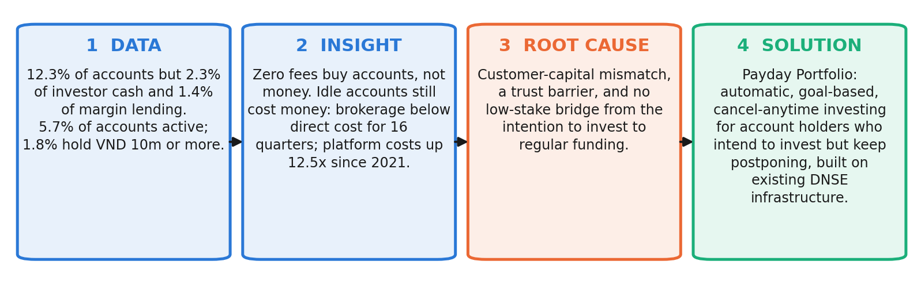
Figure 1. Storyline of the report. Source: authors.

2. Findings of observations

2.1 Evidence base and limitations
We combine six datasets: DNSE's statements reconciled to the half-year statements reviewed by KPMG, statements of 44 peers, exchange data, 1,199 cleaned DNSE app reviews, Global Findex 2024 and macro data.
Limitation: Our data centre on financial statements, customer reviews of the DNSE app, macroeconomic data, DNSE's annual reports and articles in the financial press. The largest limitation is the lack of information on the demographics of DNSE's customers and on their transactions with DNSE, so we cannot observe how DNSE's customer base is segmented. In several places our assessments can therefore only be stated as hypotheses.

2.2 Finding 1. Accounts do not bring money
The closer a measure sits to money, the smaller DNSE becomes (Figures 2 and 3). DNSE holds 12.3 per cent of accounts and 25.4 per cent of derivatives brokerage, but 2.3 per cent of investor cash, 1.4 per cent of margin lending and 0.6 per cent of industry profit. In December 2025, 5.7 per cent of accounts used any product and only 27,100 (1.8 per cent) held VND 10 million or more (DNSE Securities, 2026c). Assets per account fell 9.5 per cent in 2025 while the VN-Index rose 41 per cent. The gap is specific to DNSE: VPBankS and TCBS lend 8 and 12 times more per account, and VPS, also without a parent bank, 5 times more.
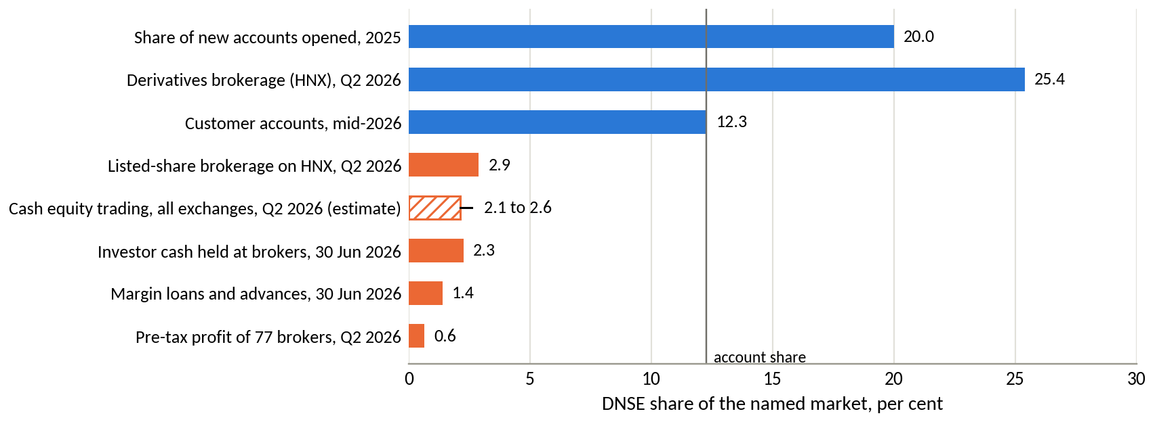
Figure 2. DNSE's share of eight markets. Source: VSDC; HNX; DNSE filings; industry tallies.
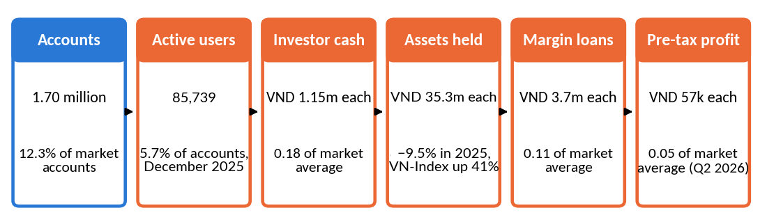
Figure 3. Where value is lost between an account and a profit. Source: DNSE filings and 2025 annual report.
Insight. DNSE has no reach problem. It loses value after the account is opened.

2.3 Finding 2. Revenue grows, but marginal cost grows faster
Revenue rose 8.1 times between 2021 and 2025, yet core profit, which excludes proprietary trading, stayed at VND 128 to 221 billion a year from 2022. Brokerage revenue has been below its direct cost for 16 consecutive quarters (Figure 4), partly because DNSE absorbs exchange and depository fees on free trades and, since May 2025, derivatives margin fees (Vietstock, 2025). In the first half of 2026 each extra VND 100 of revenue brought VND 115 of cost. The pre-tax margin fell from 23.3 to 13.2 per cent and annualised return on equity to 3.8 per cent, below a 12-month state bank deposit.
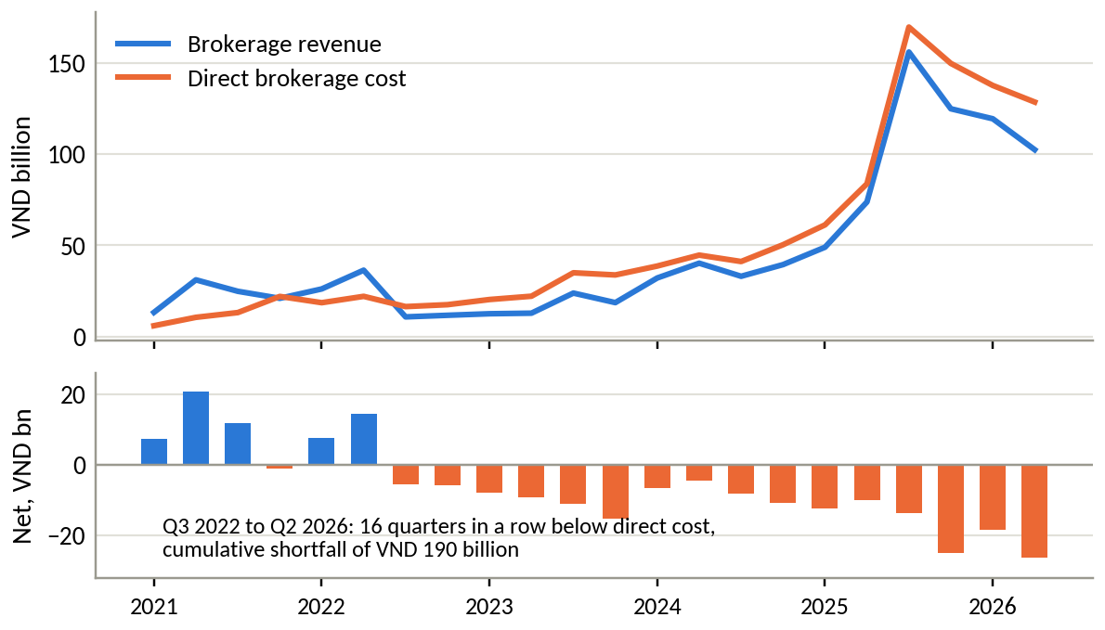
Figure 4. Brokerage revenue against direct brokerage cost, by quarter. Source: DNSE filings.
Insight. The marginal free trade loses money, so growth must come from balances, not activity.

2.4 Finding 3. Borrowing without a parent bank ties up the balance sheet
Lending is DNSE's only wide-margin business, but its estimated quarterly cost of funds rose from 3.6 per cent in mid-2024 to 6.5 per cent in the second quarter of 2026, cutting the net interest margin from 5.0 to 3.5 per cent. Short-term bank loans supply 86 per cent of borrowing, secured on pledged term deposits and bonds (DNSE Securities, 2026a, note 8b). These low-yield assets make up 37.6 per cent of DNSE's balance sheet, against 4 to 9 per cent at peers (Figure 5), whereas bank-affiliated rivals draw on parent capital and credit (Vietstock, 2026b, 2026c). DNSE's headline rate is similar to theirs, which suggests that the penalty for having no parent bank lies in collateral drag and short-term funding rather than in price.
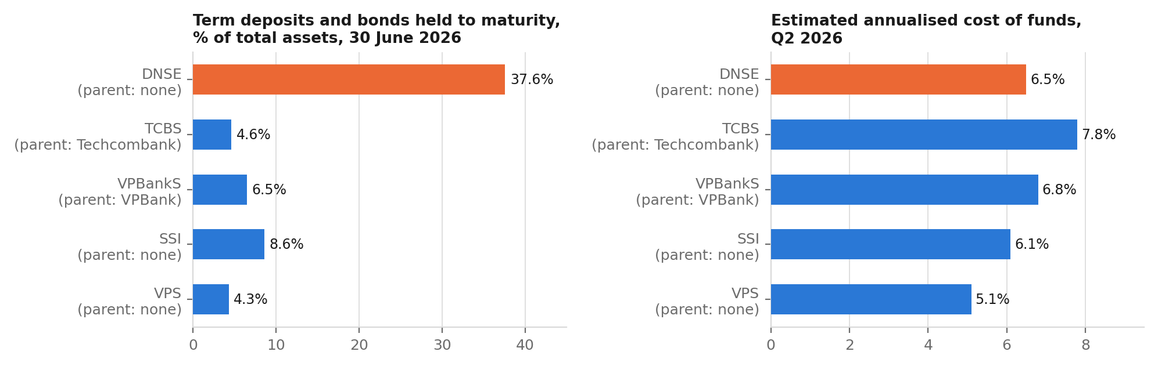
Figure 5. Funding structure against peers, second quarter of 2026. Source: filed statements via Vietcap Securities (2026).
Insight. Margin-led growth needs more expensive, collateralised debt. Fee income on customer balances is more capital-efficient.

2.5 Finding 4. Idle accounts make the technology platform a fixed-cost burden
DNSE does not disclose research and development spending, so we use a proxy: staff costs, outsourced services, and depreciation and amortisation. It rose 12.5 times between 2021 and 2025, to VND 198 billion, while revenue rose 8.1 times, and software and leased equipment at cost rose from VND 20 billion to VND 168 billion (Figure 6). Much of this investment buys speed for the most active traders, including a planned second data centre (Thời báo Tài chính Việt Nam, 2026). Spread over all accounts, the 2025 cost is VND 0.13 million each; over accounts holding VND 10 million or more, it is VND 7.3 million. When active users doubled in 2025, cost per active user fell by 39 per cent.
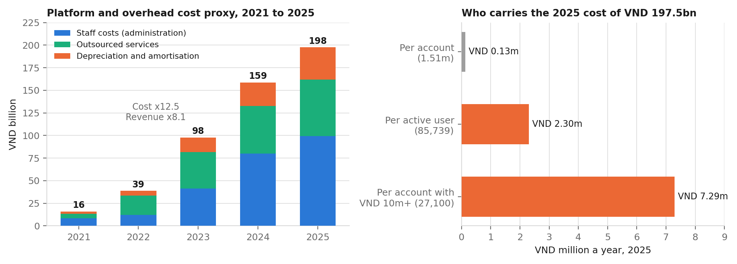
Figure 6. Platform and overhead cost proxy, and who carries it. Source: DNSE filings; DNSE Securities (2026c).
Insight. Idle accounts are verified, held in custody and served, yet fewer than 2 in 100 pay for the platform. Activating existing accounts is the cheapest way to cut unit costs.

2.6 Finding 5. Customers signal a trust deficit
Among 278 negative DNSE reviews on Google Play, crashes and login failures appear in 27 per cent and account opening and identity checks in 21 per cent. Accusations of deception, disputed sign-up bonuses and the account closure fee appear in 24 per cent but draw 43 per cent of helpful votes (Figure 7). The most-endorsed reviews say that a VND 100,000 reward required a VND 2 million deposit and that closing an account cost VND 100,000. In August 2026 the State Securities Commission (SSC) fined DNSE VND 802.5 million, stopped three derivatives financing services launched without notice and found margin lending to insiders (Market Times, 2026), following an earlier fine of VND 125 million (Thương hiệu & Công luận, 2024).
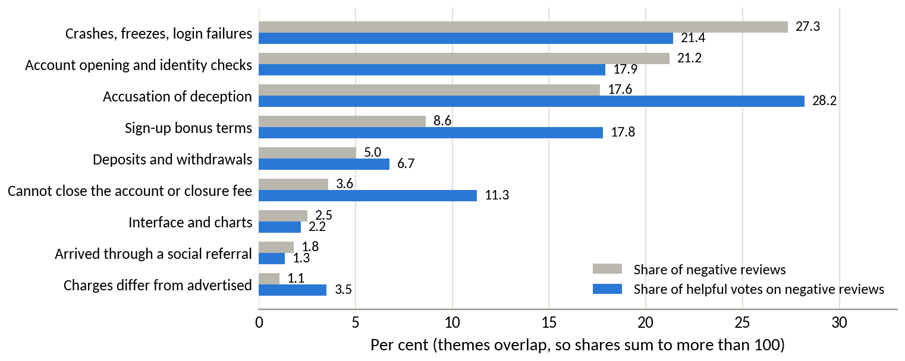
Figure 7. Themes in negative reviews, by count and by helpful votes. Source: Google Play; authors' coding.
Insight. Trust breaks at the two moments that decide funding: the first deposit and getting money out.

2.7 Finding 6. Intent without action
Findex shows that 70.5 per cent of Vietnamese adults hold an account but only 43.1 per cent save at a financial institution, a gap of 22 million adults (World Bank, 2025). Adults in the richest 60 per cent, in the labour force and with secondary education combine the largest investable surplus with strong digital habits under all four of our weighting schemes; each segment contains 15 to 20 million adults with an account but no formal saving (Figure 8). Adults aged 15 to 24 are more digital than older adults but hold less surplus than any segment outside the poorest groups, and only 8 per cent save for old age. Among investors, 36 per cent know a digital wealth platform but only 16 per cent use one, and 77 per cent find managing a portfolio difficult (Nhân Dân, 2025; VnEconomy, 2025).
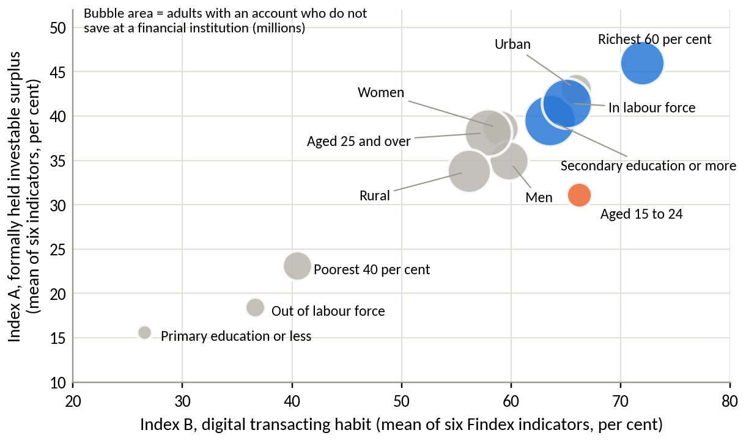
Figure 8. Adult segments by digital habit and formally held surplus. Source: World Bank (2025); authors' indices.
Hypothesis. Many Vietnamese, probably including many DNSE account holders, have an income, an account and an intention to invest, but do not act. This fits procrastination and low confidence better than a lack of access.

3. Discussion and main analysis

3.1 From symptom to root cause
Unfunded accounts are the consequence of zero-fee acquisition: when opening an account costs nothing, signing up carries no commitment to fund it. Figure 9 traces why the funding step fails.
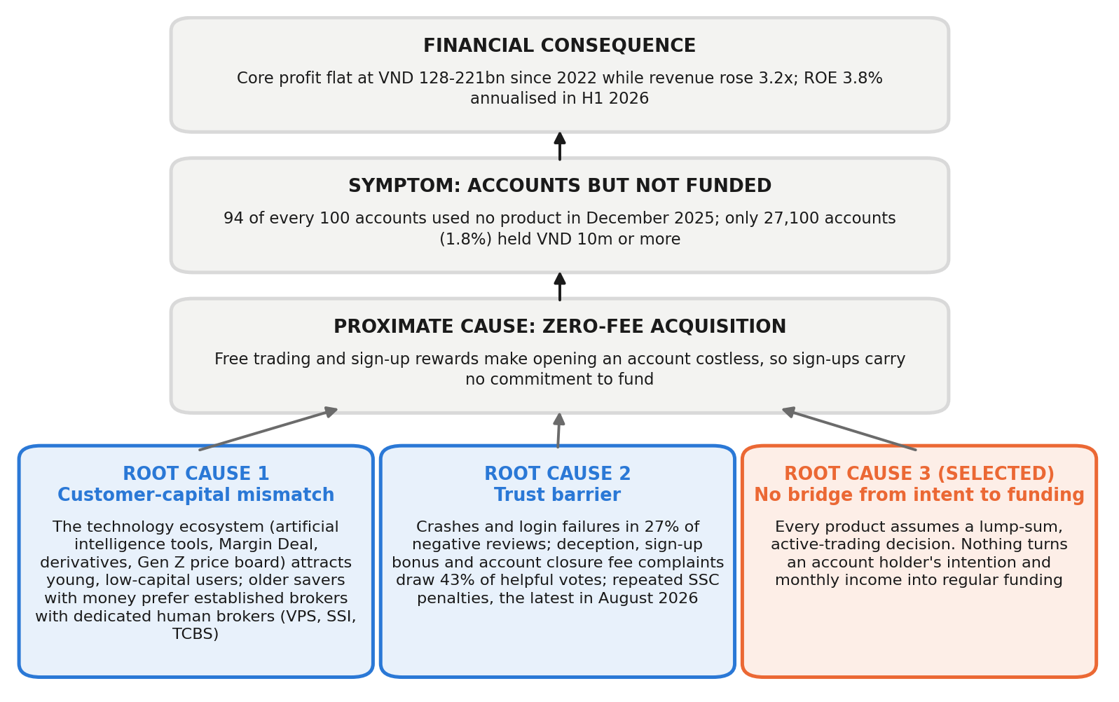
Figure 9. Root-cause tree. Source: authors' analysis.
Root cause 1: customer–capital mismatch. DNSE's artificial intelligence tools, Margin Deal, trading contests and Gen Z price board attract young, active traders, about a third of its accounts (VnExpress, 2025), who hold little capital. Older and wealthier investors prefer established brokers with dedicated human brokers: VPS, SSI and TCBS lead HOSE brokerage (CafeF, 2026a), and 81 per cent of investors want professional advice (Nhân Dân, 2025). DNSE has no advisory force and does not publish the age and wealth of its customers, so this link remains a hypothesis.
Root cause 2: trust barrier. For an app-only broker, the app is the brand. Crashes, failed identity checks, conditional rewards, a closure fee and penalties signal that money may be hard to retrieve, which matters most to savers with capital.
Root cause 3: no bridge from intent to regular funding. Every DNSE product assumes a lump sum and a wish to trade. Nothing converts a salaried customer's income and intention into regular deposits: there is no schedule, no goal and no default. People who intend to save keep postponing when every contribution is a fresh decision. Automatic enrolment lifted pension-plan participation from 37 to 86 per cent (Madrian & Shea, 2001), and pre-committed saving raised saving rates from 3.5 to 13.6 per cent (Thaler & Benartzi, 2004).
Two alternative explanations do not fit the data: the market cycle, because assets per account fell in the rising market of 2025, and a shortage of lending capital, because loans stand at 116 per cent of equity against a 200 per cent ceiling.

3.2 Customer segmentation
Table 1 separates existing customers, where the task is retention and deeper investment, from new customers, where the task is removing barriers to conversion. All sizes and barriers are hypotheses; DNSE's demographic and transaction data and the Findex microdata can test them.
Table 1. Customer segments
Segment and evidence | Main barrier (hypothesis) | Objective
Existing customers
E1. Active and funded: 85,739 active; 27,100 with VND 10m or more | App reliability; rivals' yields and credit | Retain; add a long-term goal
E2. Dormant intenders: about 1.4 million inactive accounts below VND 10m | Procrastination; no tool for small regular amounts; doubt after promotion disputes | Launch target: convert to regular funding
New customers
N1. Salaried mass-affluent, 22 to 40: 15 to 20 million adults with an account but no formal saving | No salary-to-investment bridge; doubts about an independent broker | Scale-up target
N2. Young first-time investors, 15 to 24 | Low capital, irregular income, no habit | Nurture habits cheaply
N3. Older, high-net-worth investors | Want a dedicated human broker and a bank's reputation | Deprioritise

3.3 Problem prioritisation
Table 2. Candidate problems scored from 1 (weak) to 5 (strong)
Problem | Scale (30%) | Urgency (15%) | DNSE control (25%) | Cost-efficiency of fix (15%) | Evidence (15%) | Weighted | Equal
Intent-to-funding gap | 5 | 4 | 4 | 5 | 3 | 4.30 | 4.20
Trust and reliability deficit | 3 | 5 | 5 | 4 | 4 | 4.10 | 4.20
Loss-making brokerage and platform cost | 3 | 4 | 3 | 3 | 5 | 3.45 | 3.60
Customer–capital mismatch | 5 | 3 | 2 | 1 | 3 | 3.05 | 2.80
Expensive, collateralised funding | 4 | 4 | 1 | 1 | 3 | 2.65 | 2.60

Source: authors' assessment.
The intent-to-funding gap ranks first when weighted and ties with trust under equal weights. We select it because it acts on accounts DNSE has already acquired and verified, and because trust fixes alone create no deposits: TCBS runs a similar zero-fee app, yet about a third of its customers trade monthly (TCBS, 2026b). A funding product designed around trust addresses both problems.
Problem statement. DNSE lacks a trusted, low-stake mechanism that turns account holders' intention to invest into regular funding. As a result, 98 per cent of its accounts hold under VND 10 million and fewer than 2 in 100 carry the cost of its platform.

3.4 Strategic alternatives and trade-offs
Table 3. Alternatives scored from 1 to 5 (for cost and risk, higher means lower)
Option | Funded balances (30%) | Low cost (20%) | Reuses infrastructure (15%) | Trust fit (15%) | Speed (10%) | Evidence (10%) | Weighted | Equal
B. Payday Portfolio with trust package | 5 | 3 | 5 | 4 | 2 | 4 | 4.05 | 3.83
A. Trust and reliability programme only | 2 | 4 | 4 | 5 | 4 | 3 | 3.45 | 3.67
D. Reprice Tài khoản không ngủ | 3 | 1 | 5 | 3 | 5 | 3 | 3.10 | 3.33
C. Advisory tier with dedicated human brokers | 4 | 1 | 1 | 3 | 2 | 3 | 2.50 | 2.33
E. More sign-up rewards (status quo) | 1 | 2 | 5 | 1 | 4 | 2 | 2.20 | 2.50

A trust programme alone (A) is necessary but insufficient, so it becomes the first phase of B. Repricing Tài khoản không ngủ (D) is fast but starts a yield contest: each extra point on VND 1.96 trillion of investor cash costs about VND 20 billion a year without bringing new money. An advisory tier (C) needs advisers DNSE lacks, and more sign-up rewards (E) buy accounts, not balances. Payday Portfolio (B) ranks first under both weightings. It sacrifices speed: balances build month by month and cannot rescue the 2026 profit plan.

4. Recommendations

4.1 Payday Portfolio, positioned for the customer who intends to invest
Payday Portfolio targets salaried customers who intend to invest but keep postponing: first DNSE's dormant account holders with a salary (E2), then new salaried customers (N1). It does not target those who fundamentally distrust DNSE (N3).
A payday product can look counterintuitive when trust is the barrier. Trust, however, blocks a large one-off commitment, and Payday Portfolio asks for none. It asks for a small, reversible amount each month under the customer's control, and each transfer that arrives safely and can be withdrawn at once builds a track record. For a procrastinator the obstacle is the monthly decision, so we expect automation to be a stronger lever than a higher yield, a hypothesis that Table 7 tests.
The product works in four steps (Figure 10). The customer sets a goal and an amount, from VND 500,000, once. A standing order in the customer's own banking app, or a ZaloPay authorisation, moves the money on payday; DNSE never debits a bank account. Cash waits briefly in Tài khoản không ngủ and is then invested by goal, in Trứng Vàng bonds first and in bond funds, equity funds or VN30 exchange-traded funds if the customer opts in. Ensa acts as a goal coach. Margin is excluded at launch.
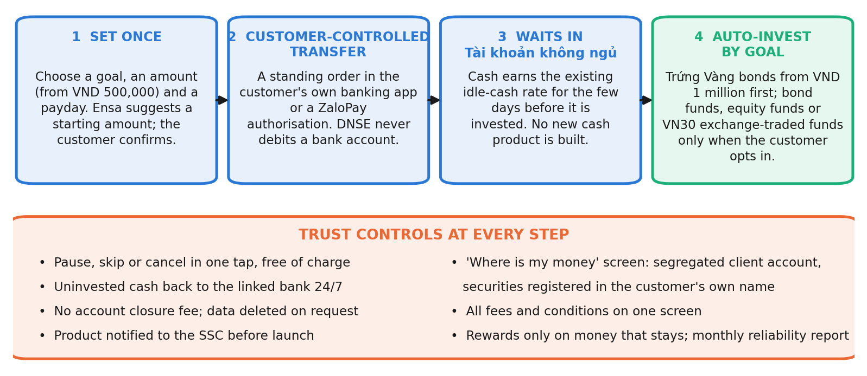
Figure 10. How Payday Portfolio works. Source: authors' design.

4.2 Trust by design
Table 4. Customer fears, design responses and published proof
Customer fear | Design response | Published proof
"I cannot get my money out" | Cash back to the linked bank 24/7; no closure fee | Median withdrawal time
"I will be locked in" | Pause, skip or cancel in one tap, free | Cancellations completed in the app
"There are hidden conditions" | All terms on one screen; rewards only on money that stays | Trust themes under 10% of negative reviews (24% today)
"Where is my money?" | View of the segregated client account and securities held in the customer's name | Monthly statement
"The app crashes" | Transfers run as scheduled back-end jobs; reliability is a launch gate | Transfer success of 99.5% or more
"Is it legal?" | Product notified to the SSC before launch | Written confirmation

4.3 Payday Portfolio and Tài khoản không ngủ
Table 5. Two products, two jobs
 | Tài khoản không ngủ | Payday Portfolio
Job | Earns a return on cash already deposited | Brings new money in and invests it regularly
Customers | Active traders with idle cash (E1) | Salaried intenders who have not funded (E2, N1)
Trigger | Customer decides to deposit | Payday, automatically
Return | 1.8% base plus bonuses for large balances and trading value | Chosen bonds, funds and exchange-traded funds
Behavioural lever | None | Default, automation and goal tracking

Source: DNSE Securities (2026b); authors' design.
The products do not compete: one keeps existing cash, the other brings in new money from small, regular savers. Payday Portfolio uses Tài khoản không ngủ as its transit cash layer, so every payday lifts its balances and no new cash product is needed. Round 3 should confirm that at least 80 per cent of inflows are new money.

4.4 Value logic and cost optimisation
Payday Portfolio earns distribution fees on bonds, funds and exchange-traded funds. Its larger contribution is to DNSE's cost structure:
- Reuse. Verified accounts, Tài khoản không ngủ, Trứng Vàng, exchange-traded fund trading, ZaloPay and Ensa already exist; the new build is a scheduling and goal engine.
- Lower unit cost. In the base case, accounts holding VND 10 million or more rise from 27,100 to about 177,000, cutting platform cost per such account from VND 7.3 million to about VND 1.1 million before incremental costs (team estimate).
- Positive-margin activity. Distribution earns fees; each free trade costs fees.
- No new borrowing. Fee income grows without collateralised debt.
- Better-directed spending. Rewards shift from sign-ups to funding, and development from speed for the active 6 per cent to engagement for the idle 94 per cent.
Table 6. Outcomes 18 months after launch (all inputs are assumptions)
 | Conservative | Base | Upside
Savers | 60,000 | 150,000 | 300,000
Monthly contribution, VND million | 1.0 | 1.5 | 2.5
Share kept on platform | 60% | 70% | 80%
Assets, VND trillion | 0.65 | 2.84 | 10.80
Multiple of current investor cash | 0.3 | 1.4 | 5.5
Annual fees, VND billion | 3 | 23 | 108
Accounts with VND 10m or more | 5.1% | 10.4% | 19.2%

Source: authors' projections.
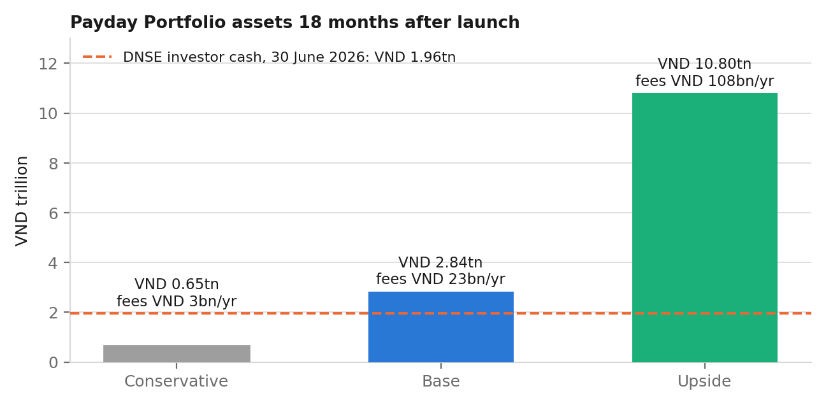
Figure 11. Payday Portfolio assets under three scenarios. Source: Table 6.
Direct revenue is modest: base-case fees of VND 23 billion equal 1.6 per cent of 2025 revenue. The value lies in funded balances, lower unit costs and a base for later fee and lending income.

4.5 Validation direction
Table 7. Priority assumptions and Round 3 tests
# | Assumption | Test | Threshold
1 | Many dormant accounts belong to salaried intenders | Internal data; survey of 2,000 dormant customers | 30% or more say they intend to invest
2 | Automation turns intent into funding | Randomised pilot, 20,000 customers, against a standard reactivation message | 15% enrol in 60 days; 70% of money kept at day 90
3 | Trust features raise set-up | A/B test of the trust screen | Set-up completion up 5 points
4 | A compliant structure exists (gate) | SSC pre-consultation; partner terms | Written confirmation
5 | Reliability meets the standard (gate) | Load tests; shadow payday runs | 99.5% transfer success
6 | Unit costs fall | Incremental cost against balances | Cost per funded customer below today's
7 | No cannibalisation of Tài khoản không ngủ | Tag the source of inflows | 80% new money

The headline KPI is the share of accounts holding VND 10 million or more, which DNSE already reports: 1.8 per cent today, with a target of 5 per cent within 18 months. Supporting KPIs are the active rate (5.7 per cent), net new money, platform cost per funded account (VND 7.3 million) and trust themes in reviews (24 per cent). Tests 4 and 5 and the data pull run in months 0 to 2, the pilot in months 3 to 6, and the scale decision follows at month 6.

5. Conclusion
DNSE has solved getting noticed but not getting customers to keep money with it. Unfunded accounts follow from zero-fee acquisition; their roots are an ecosystem that attracts low-capital customers, a trust deficit that deters those with capital, and no low-stake path from intending to invest to investing regularly. Payday Portfolio acts on the root cause DNSE controls most: it turns intention into habit, earns trust in small reversible steps, complements Tài khoản không ngủ and uses infrastructure DNSE has already paid for. Round 3 should first establish who the dormant customers are, then test the concept in a randomised pilot.

Appendices

Appendix A. Data preparation and cleaning
Table A1. Evidence base
Dataset | Coverage | Main preparation step
DNSE financial statements | 395 line items, Q1 2018 to Q2 2026 | Pulled line by line from Vietcap IQ; reconciled to the half-year statements reviewed by KPMG
DNSE and peer indicators | Accounts, active users, customer assets, product terms; statements of 44 brokers | Each figure dated and cross-checked with a second source where possible
Exchange and industry data | HOSE and HNX brokerage shares; industry lending, investor cash and profit | Each share kept within its own market; broadest industry total used
App store reviews | 867 Google Play and 332 App Store reviews of DNSE; 2,100 of VPS and FPTS | Spam and duplicates removed; 670 DNSE Google Play reviews retained and coded by theme
World Bank Global Findex 2024 | 51 indicators across 13 segments, Vietnam | Two indices built; segments ranked under four weighting schemes
Macro and banking data | Growth, inflation, credit, deposit rates, household deposits | Dated at source; projections labelled

Source: compiled by the authors; access dates 20 to 25 September 2026.
A1. Financial statements. 395 line items of DNSE's income statement, balance sheet, cash flow and notes were pulled from Vietcap IQ for Q1 2018 to Q2 2026 and reconciled to the half-year statements reviewed by KPMG. Where the quarterly filing (second-quarter pre-tax profit VND 98.9 billion) differed from the reviewed half year (implied VND 97.4 billion), the reviewed figure was used. Template line 24 combines loan-loss provisions with the funding cost of the loan book, so the cost of funds is estimated as interest expense plus line 24, less the rise in the balance-sheet allowance for loan losses, over average borrowings. The same method is applied to all peers.
A2. Denominators. HOSE and HNX report market share within their own exchange, so shares are never compared across exchanges. Industry lending (VND 453.8 trillion including advances) and investor cash (VND 86.6 trillion) use the broader published totals; narrower totals raise DNSE's shares by about 0.1 point and do not change any conclusion. The market account count (VSDC) and DNSE's count both include inactive accounts.
A3. Platform cost proxy. DNSE does not report research and development. The proxy sums staff costs and outsourced services from the note on general and administrative expenses and total depreciation and amortisation from the cash flow statement. It may include non-technology overheads and exclude technology staff costs booked under brokerage expenses; it is used for trend and order of magnitude only.
Table A2. Review cleaning log
Stage | DNSE, Play | VPS, Play | FPTS, Play | DNSE, iOS | VPS, iOS | FPTS, iOS
Reviews retrieved | 867 | 1,200 | 177 | 332 | 518 | 205
Loan advertising removed | 127 | 23 | 0 | 0 | 0 | 0
Referral farming removed | 70 | 3 | 0 | 73 | 6 | 0
Duplicates removed | 0 | 3 | 0 | 0 | 0 | 0
Reviews retained | 670 | 1,171 | 177 | 259 | 512 | 205
Mean rating before cleaning | 3.29 | 2.60 | 2.18 | 3.37 | 1.57 | 2.31
Mean rating after cleaning | 3.22 | 2.58 | 2.18 | 2.94 | 1.53 | 2.31

Source: Google Play (23 September 2026) and Apple App Store (24 September 2026); authors' cleaning code. Text was normalised (Unicode compatibility composition, diacritics removed, lower case) before two rules flagged loan advertising and referral farming; the referral rule fires only where a referral phrase sits next to a code or reward amount, and passes 37 test cases. Copy-and-paste duplicates of 20 characters or more were removed. One-word reviews were flagged as generic.
Cleaning changed the conclusions: in 2022 and 2023, 46 and 54 per cent of DNSE's Google Play reviews were spam, and the removed material was rated higher than the genuine reviews (3.53 against 3.22).

Appendix B. DNSE financial data
Table B1. Income statement summary, VND billion
Item | 2021 | 2022 | 2023 | 2024 | 2025 | H1 2026
Operating revenue | 180.7 | 452.1 | 714.5 | 807.4 | 1,457.9 | 848.2
Interest on margin loans and advances | 42.7 | 223.1 | 286.2 | 360.5 | 555.8 | 336.1
Interest on deposits and bonds held to maturity | 20.1 | 112.9 | 196.0 | 245.0 | 303.9 | 193.4
Brokerage revenue | 90.0 | 84.8 | 67.6 | 144.8 | 404.0 | 222.1
Direct brokerage cost | 51.5 | 74.4 | 111.1 | 174.8 | 464.9 | 266.5
Interest expense plus line 24 | 23.9 | 172.2 | 233.6 | 210.6 | 429.8 | 324.1
Administrative expenses | 14.8 | 37.1 | 94.3 | 151.9 | 181.4 | 95.4
Pre-tax profit | 68.2 | 95.0 | 285.6 | 227.5 | 340.2 | 111.6
Net proprietary result | (4.4) | (61.3) | 158.0 | 6.8 | 146.2 | 33.9
Core pre-tax profit | 72.5 | 156.3 | 127.6 | 220.7 | 194.0 | 77.7

Source: DNSE filed statements via Vietcap Securities (2026); H1 2026 from the half-year statements reviewed by KPMG; authors' calculations. Core pre-tax profit excludes the net result on financial assets at fair value through profit or loss.
Table B2. Balance sheet and key ratios
Item | 2021 | 2022 | 2023 | 2024 | 2025 | Jun 2026
Margin loans and advances, VND bn | 1,192 | 2,280 | 2,483 | 3,882 | 5,832 | 6,303
Deposits and bonds held to maturity, VND bn | 883 | 2,824 | 3,495 | 5,103 | 6,266 | 5,714
Total assets, VND bn | 2,315 | 6,409 | 7,446 | 10,637 | 15,139 | 15,208
Borrowings and bonds, VND bn | 1,224 | 2,735 | 3,643 | 6,494 | 10,600 | 9,446
Owners' equity, VND bn | 1,059 | 3,136 | 3,305 | 4,030 | 4,302 | 5,440
Investor cash (off balance sheet), VND bn | 435 | 251 | 790 | 1,340 | 2,903 | 1,961
Pre-tax margin, % | 37.7 | 21.0 | 40.0 | 28.2 | 23.3 | 13.2
Brokerage revenue as % of direct cost | 174.9 | 114.0 | 60.9 | 82.8 | 86.9 | 83.3
Return on equity, % | 8.9 | 3.7 | 7.1 | 5.0 | 6.5 | 3.8
Loans as % of equity (ceiling 200) | 112.6 | 72.7 | 75.1 | 96.3 | 135.6 | 115.9
Estimated cost of funds, % | 6.5 | 6.8 | 7.3 | 4.1 | 5.1 | 6.3
Net interest margin, % | 6.2 | 5.4 | 4.8 | 5.0 | 4.2 | 3.5

Source: as Table B1. H1 2026 return on equity is annualised.
Table B3. Platform and overhead cost proxy, VND billion
Item | 2021 | 2022 | 2023 | 2024 | 2025
Staff costs (administration) | 8.6 | 12.1 | 41.2 | 80.0 | 99.4
Outsourced services | 4.8 | 21.5 | 40.4 | 52.8 | 62.7
Depreciation and amortisation (all) | 2.4 | 5.0 | 16.2 | 25.9 | 35.4
Platform cost proxy | 15.8 | 38.7 | 97.8 | 158.8 | 197.5
Software and leased equipment at cost | 20.0 | 44.7 | 95.7 | 129.1 | 168.5
Accounts at year end | 44,727 | 189,845 | about 560,000 | about 994,000 | 1,512,920
Active users, December | n.a. | n.a. | n.a. | about 41,900 | 85,739
Proxy per active user, VND million | n.a. | n.a. | n.a. | 3.79 | 2.30

Source: DNSE filed statements (notes on administrative expenses; cash flow statement; notes on intangible and finance-lease assets); DNSE Securities (2026c); Vietstock (2026a); authors' calculations. End-2024 accounts are end-2025 accounts less the 518,514 opened in 2025.
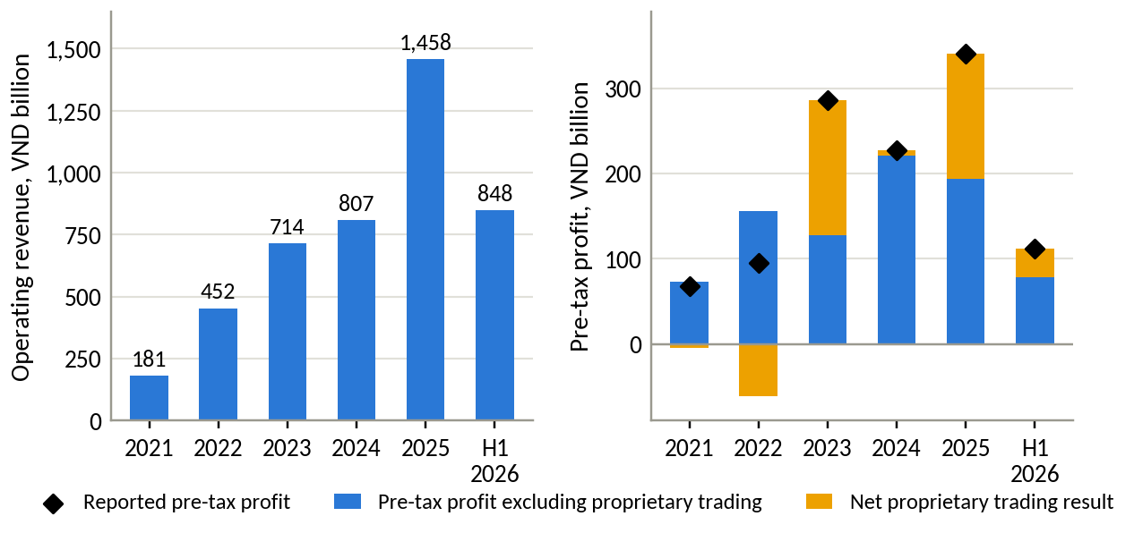
Figure B1. Operating revenue and pre-tax profit split into core business and proprietary trading. Source: DNSE filings; authors' calculations.
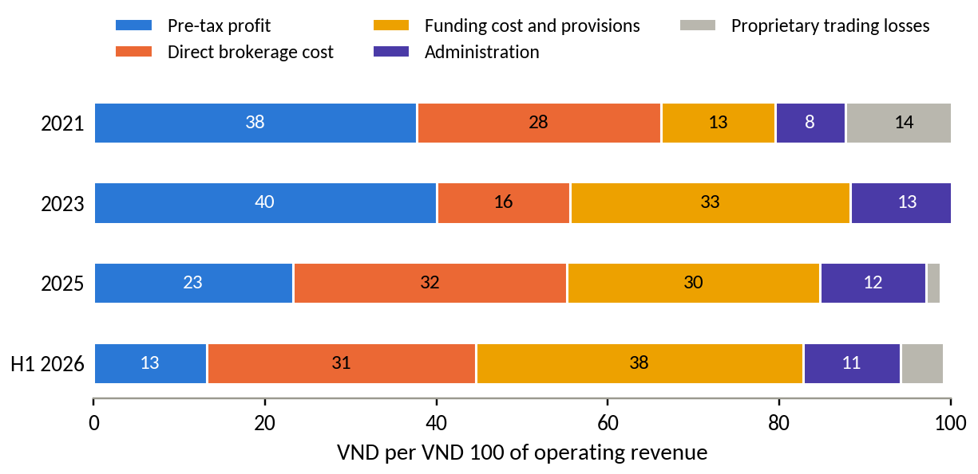
Figure B2. Where each VND 100 of operating revenue goes. Source: DNSE filings; authors' calculations.
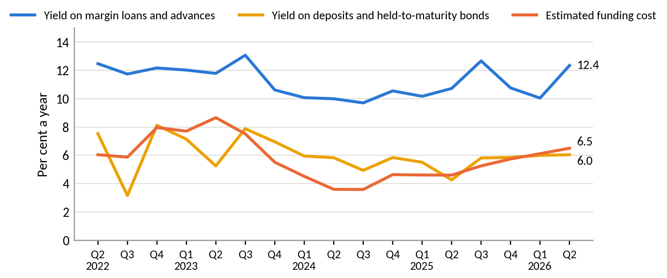
Figure B3. Yield on margin loans and on deposits and bonds held to maturity, against the estimated cost of funds. Source: DNSE filings; authors' calculations.
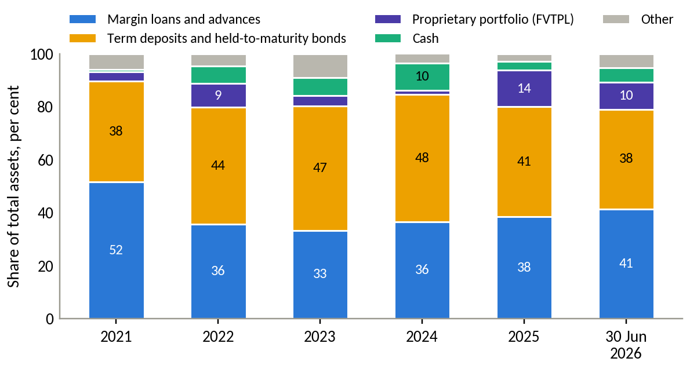
Figure B4. Composition of DNSE total assets. Source: DNSE filings.

Appendix C. Market and peer data
Table C1. DNSE's position on eight measures
Measure | DNSE | Market total | DNSE share, % | Ratio to account share
Securities accounts, mid-2026 | 1.70 million | 13.85 million | 12.27 | 1.00
New accounts, 2025 | 518,514 | about 2.57 million | 20.00 | 1.63
Derivatives brokerage, Q2 2026 | 2nd place | HNX | 25.38 | 2.07
Listed-share brokerage on HNX, Q2 2026 | 8th place | HNX | 2.88 | 0.23
Cash equity trading, Q2 2026 (estimate) | VND 62.9 trillion | all exchanges | 2.13 | 0.17
Investor cash at brokers, 30 June 2026 | VND 1,961 billion | VND 86.6 trillion | 2.26 | 0.18
Margin lending, 30 June 2026 | VND 6,303 billion | VND 453.8 trillion | 1.39 | 0.11
Pre-tax profit, Q2 2026 | VND 97.4 billion | VND 15,200 billion | 0.64 | 0.05

Source: VnExpress (2026); Vietstock (2026a, 2026d); CafeF (2026b); VnEconomy (2026); Hanoi Stock Exchange (2026); DNSE filings; authors' calculations.
Table C2. DNSE against named peers
Indicator | DNSE | VPBankS | TCBS | VPS
Customer accounts, million | 1.70 | 1.30 | 1.20 | 1.55
Margin lending, 30 June 2026, VND bn | 6,303 | 38,200 | 51,500 | 31,300
Lending per account, VND million | 3.7 | 29.4 | 42.9 | 20.2
Pre-tax profit per account, Q2 2026, VND thousand | 57 | 1,661 | 1,748 | 891
Deposits and bonds held to maturity, % of assets | 37.6 | 6.5 | 4.6 | 4.3
Estimated cost of funds, Q2 2026, % | 6.5 | 6.8 | 7.8 | 5.1
Parent bank | none | VPBank | Techcombank | none

Source: filed statements via Vietcap Securities (2026); company releases for account counts (VPBankS May 2026; TCBS end-2025; VPS September 2025); authors' calculations. Per-account values are averages that large clients raise at every firm.
Table C3. Competitive landscape of Vietnamese retail brokerage and savings
Model | Examples | How it earns | Strength | Gap for salaried savers
Bank-affiliated brokers | TCBS, VPBankS, MBS | Margin lending, bond distribution | Cheap funding, capital, parent-bank customers and trust | Serve mainly their parents' customers; TCBS iPower pays interest only above VND 5 million
Independent full-service brokers | SSI, HSC, Vietcap | Margin, institutional brokerage, advisory | Research, brand, human brokers | Costly to serve small savers
Retail trading platforms | VPS | Retail and derivatives brokerage, margin | Largest retail share | trading-first; no link from a salary
Zero-fee digital brokers | DNSE, Pinetree | Margin, derivatives | Low cost, fast technology, young customers | Small balances; no regular-saving product
Banks' automatic-earning accounts | Large commercial banks | Deposit spread | Salary accounts, trust | Little choice beyond deposits

Source: company statements and product pages; TCBS (2026a); Vietstock (2026c); authors' assessment.
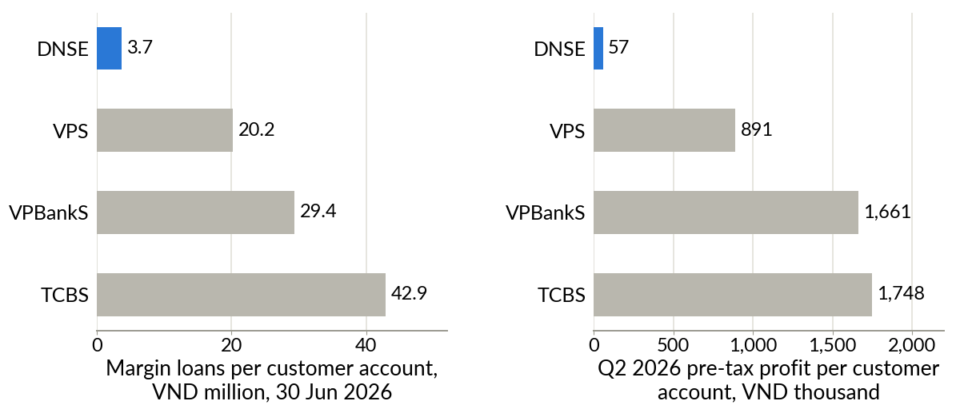
Figure C1. Lending and profit per customer account, DNSE against VPS, VPBankS and TCBS. Source: as Table C2.
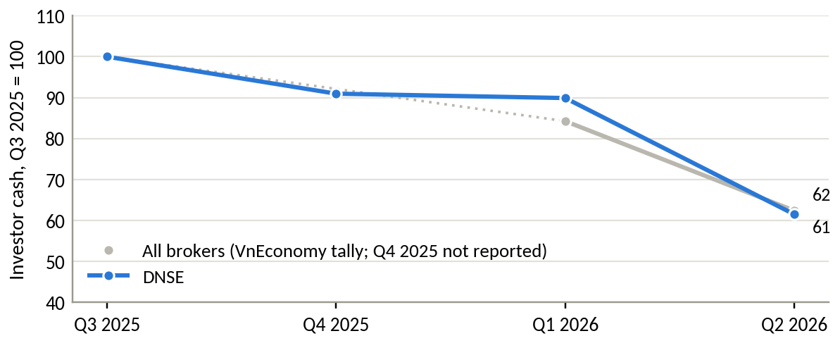
Figure C2. Investor cash held at brokers, indexed to the third quarter of 2025. Source: VnEconomy (2026); DNSE filings.
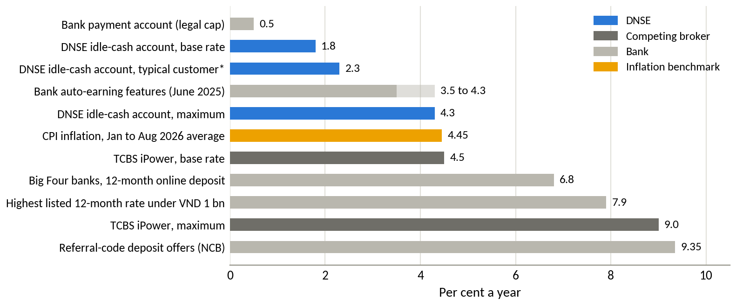
Figure C3. Returns available to a Vietnamese saver's idle cash, September 2026. Source: DNSE Securities (2026b) and TCBS (2026a) product pages; bank rate surveys.

Appendix D. Customer review analysis
Table D1. Themes in DNSE's negative Google Play reviews
Theme | Negative reviews | Share of negative reviews, % | Share of helpful votes, %
Crashes, freezes, login failures, slow orders | 76 | 27.3 | 21.4
Account opening, identity checks, one-time passwords | 59 | 21.2 | 17.9
Explicit accusation of deception | 49 | 17.6 | 28.2
Sign-up bonus terms, rewards not received | 24 | 8.6 | 17.8
Deposits not credited, withdrawal delays | 14 | 5.0 | 6.7
Cannot close the account, closure fee | 10 | 3.6 | 11.3
Any trust theme (deception, bonus terms, closure) | 67 | 24.1 | 42.9
Any product theme (stability, onboarding) | 118 | 42.4 | 34.1
Idle-cash product (Tài khoản không ngủ), all reviews | 3 mentions, all positive

Source: Google Play, retrieved 23 September 2026; authors' coding. 278 one- and two-star reviews carrying 1,794 helpful votes. Themes are not exclusive.
Table D2. Selected DNSE reviews, translated from Vietnamese
Date | Stars | Helpful votes | Review
9 Jun 2025 | 1 | 58 | "Everyone, be careful, it is a scam. You do not receive the 100k. To delete your account you have to pay it 100k."
24 May 2025 | 1 | 54 | "I have been trapped ... you cannot cancel the registration ... after approval you have to go to the head office to delete the account."
28 Jun 2025 | 1 | 50 | "Deceptive and false. There is no 100k straight away. You have to deposit at least 2 million to get it."
2 Jun 2025 | 2 | 18 | "When I deposit outside trading hours, the money leaves my bank account but the securities account does not receive it."
15 May 2026 | 5 | 13 | "... The idle account is the best. Watching the interest rise in real time is satisfying, and money earns interest automatically once it is deposited."

Source: Google Play; translated by the authors.
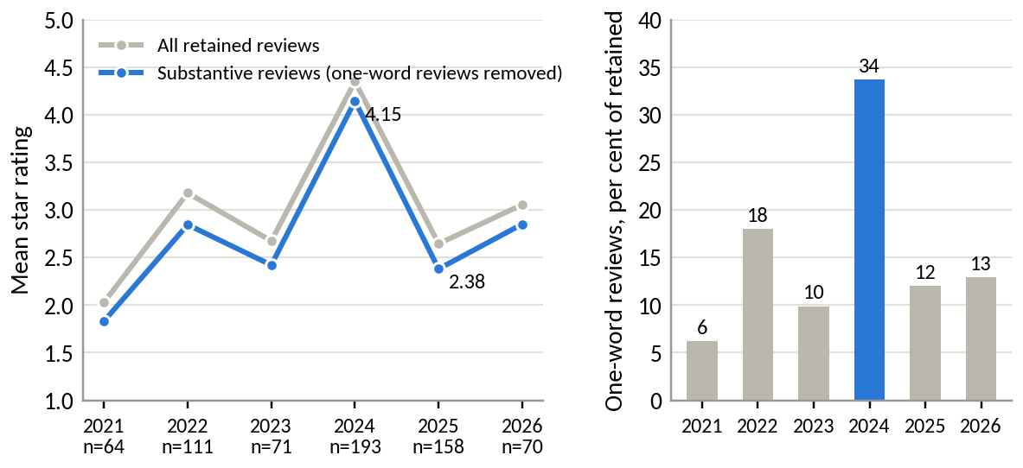
Figure D1. Mean rating of DNSE reviews by year, and the share of one-word reviews. Source: Google Play; authors' cleaning.
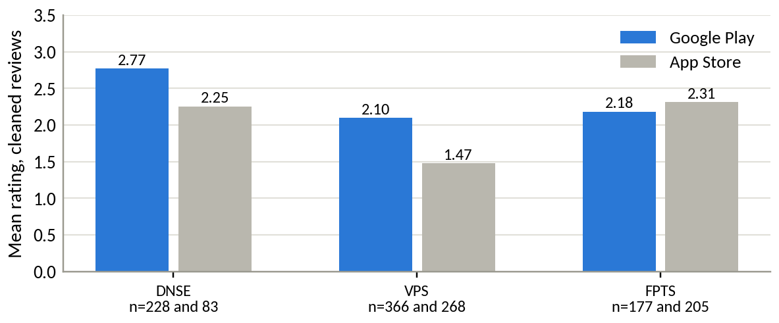
Figure D2. Mean rating of cleaned reviews on Google Play and the App Store, 2025 and 2026. Source: Google Play and Apple App Store; authors' cleaning.
Regulatory record. Decision 461 of the securities inspectorate, issued on 17 August 2026, imposed VND 802.5 million of fines for derivatives financing services offered without prior notice (January 2024 to June 2026), margin lending to insiders and related persons, and purchases beyond available funds, and ordered the three services to stop (Market Times, 2026; Phụ nữ Việt Nam, 2026). An earlier fine of VND 125 million concerned margin lending on a stock removed from the marginable list (Thương hiệu & Công luận, 2024). Press reports also cite a 2023 fine of VND 125 million; the original SSC decisions have not yet been cross-checked.

Appendix E. Findex segment analysis
Table E1. Findex indicators for selected segments, Vietnam, 2024 fieldwork (per cent of adults)
Segment | Share of adults | Index A (surplus) | Index B (digital) | Has an account | Saved at an institution | Gap, points | Unconverted adults, million | Wages into an account | Saved for old age
All adults | 100.0 | 36.8 | 59.4 | 70.5 | 43.1 | 27.5 | 22.1 | 37.0 | 20.2
Aged 15 to 24 | 18.2 | 31.1 | 66.2 | 72.2 | 38.6 | 33.6 | 4.9 | 36.9 | 8.2
Aged 25 and over | 81.8 | 38.1 | 57.9 | 70.2 | 44.1 | 26.1 | 17.2 | 37.0 | 22.8
Secondary education or more | 88.8 | 39.5 | 63.5 | 75.2 | 46.7 | 28.5 | 20.4 | 40.4 | 21.7
Richest 60% | 60.0 | 46.0 | 72.0 | 85.5 | 53.8 | 31.7 | 15.3 | 49.5 | 26.5
In labour force | 79.9 | 41.5 | 65.1 | 77.9 | 48.4 | 29.5 | 19.0 | 45.2 | 23.2
Poorest 40% | 40.0 | 23.1 | 40.5 | 48.1 | 27.1 | 21.1 | 6.8 | 18.1 | 10.6

Source: World Bank (2025); authors' indices. Index A averages six indicators of formally held surplus (saving at an institution, monthly saving into an account, storing money in an account, receiving interest, saving for old age, covering two months without income). Index B averages six indicators of digital habit (digitally enabled account, daily internet use, smartphone, weekly card or mobile payment in store, checking a balance by phone, wages into an account). Twelve segments were ranked on six min-max normalised criteria under four weighting schemes; the richest 60 per cent and adults in the labour force ranked first and second under all four, and adults aged 15 to 24 ranked seventh to ninth. With about 1,000 interviews, the 15-to-24 group rests on roughly 180 respondents, so small differences in rank sit within sampling error.
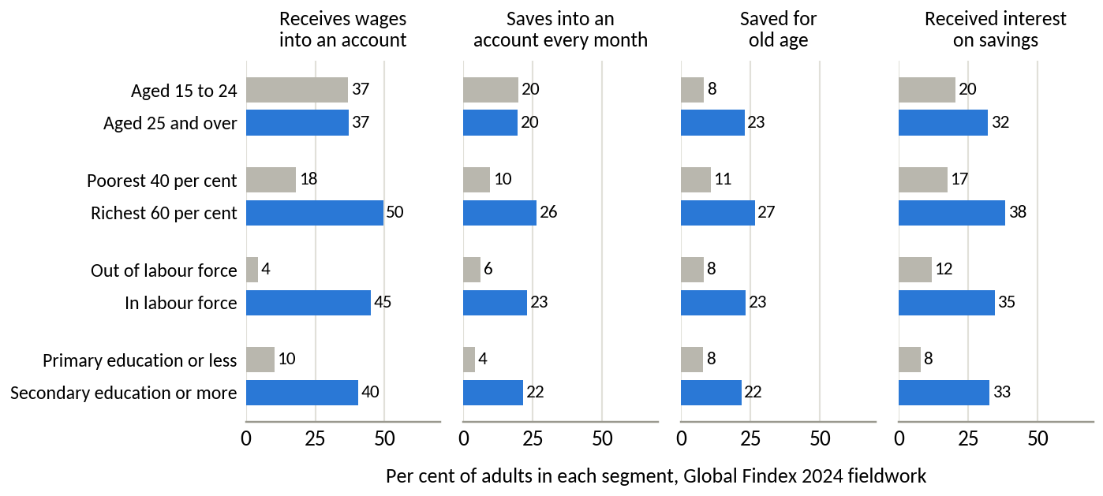
Figure E1. Payday and saving behaviour by segment pair. Source: World Bank (2025).

Appendix F. Assumptions and limitations register
Item | Type | Effect if wrong | How Round 3 tests it
Segment sizes and barriers (Table 1) | Hypothesis | Wrong target or message | DNSE internal data; Findex microdata; survey
Share of dormant accounts held by intenders | Hypothesis | Enrolment falls short | Test 1 (survey and internal data)
Automation and trust features raise funding | Hypothesis, supported by research abroad | Concept fails the pilot | Tests 2 and 3 (randomised pilot, A/B test)
Scenario inputs: savers, contribution, retention, fee yield | Assumption | Scale of outcomes changes proportionally | Pilot read-out at month 6
Platform cost proxy | Derived proxy | Level may be over- or understated; trend robust | DNSE management accounts
Cost of funds for DNSE and peers | Derived | Line 24 may include more provisions than assumed | Notes on borrowing terms
Account counts differ in date and definition | Measured, mixed dates | Per-account values shift by up to about 10 per cent | Internal account register
App reviews are self-selected | Measured, biased sample | Levels overstate dissatisfaction; comparisons across themes and years are more reliable | Complaint logs; customer survey
Gen Z share of DNSE accounts | External estimate | Weaker or stronger mismatch | DNSE demographic data
Regulatory feasibility | Assumption | Launch delayed | Test 4 (SSC pre-consultation)

F1. Scale anchors for Table 2. Intent-to-funding gap: about 1.4 million inactive accounts below VND 10 million that DNSE has already paid to acquire and verify (end-2025 accounts less active users and accounts holding VND 10 million or more). Trust deficit: indirect, since it blocks conversion of the same base. Brokerage and platform cost: about VND 89 billion a year below direct cost (first half of 2026, annualised), with a platform cost proxy of VND 197.5 billion in 2025. Customer–capital mismatch: the largest pool of money, but slow and costly to change. Funding: cost of funds up about 3 points since mid-2024, on VND 9.4 trillion of borrowing.
F2. Scenario method for Table 6. Assets per saver equal the monthly contribution times the share kept times 18 months, before investment returns (VND 10.8, 18.9 and 36.0 million). Payday Portfolio assets equal assets per saver times the number of savers. Annual fees apply a yield of 0.5, 0.8 and 1.0 per cent to assets, covering bond and fund distribution. The share of accounts holding VND 10 million or more adds the savers to the 27,100 accounts already above that level and divides by 1.7 million accounts, assuming savers were below VND 10 million at enrolment. The base case needs about one in eleven accounts to enrol, 1.75 times the customers active in December 2025. Costs of incentives, marketing and technology are estimated in Round 3 (test 6).
F3. Alternative explanations tested. (1) Market cycle: rejected, because assets per account fell 9.5 per cent in 2025 while the VN-Index rose 41 per cent, and the 2026 outflow of investor cash hit all brokers in similar proportion. (2) Shortage of lending capital: rejected, because loans were 116 per cent of equity against a 200 per cent ceiling, leaving room for about VND 4.6 trillion more. (3) A deliberate "acquire young, monetise later" strategy: cannot be rejected with public data; cohort data by year of account opening would settle it. (4) Every broker counts dormant accounts: the named-peer comparison in Table C2 holds on similar account counts.

References
CafeF. (2026a, July 6). Thị phần môi giới HoSE quý 2/2026: VPS xuống thấp nhất 22 quý, SSI và TCBS áp sát [HOSE brokerage shares in Q2 2026]. https://cafef.vn/thi-phan-moi-gioi-hose-quy-2-2026-vps-xuong-thap-nhat-22-quy-ssi-va-tcbs-ap-sat-188260706171935801.chn
CafeF. (2026b, July 22). Soi số lợi nhuận 15.200 tỷ của ngành chứng khoán trong quý 2 [The securities industry's VND 15,200 billion profit in Q2]. https://cafef.vn/soi-so-loi-nhuan-15200-ty-cua-nganh-chung-khoan-trong-quy-2-mot-cuoc-doi-ngoi-dang-am-tham-dien-ra-188260722020054991.chn
DNSE Securities. (2026a). Financial statements and investor relations releases, 2019 to the second quarter of 2026. https://ir.dnse.com.vn/vi/ctype-finance_report
DNSE Securities. (2026b). Tài khoản Không Ngủ [Idle-cash account, product page]. Retrieved September 24, 2026, from https://www.dnse.com.vn/san-pham/tai-khoan-khong-ngu
DNSE Securities. (2026c). Báo cáo thường niên 2025 [Annual report 2025]. https://cdn.dnse.com.vn/dnse-assets/CBTT/DSE%20-%20BCTN%202025.pdf
FiinRatings. (2026). Banking sector: FY2025 recap and 2026 outlook. https://fiinratings.vn/Data/2026/Report/FiinRatings_Vietnam-Banking-2026-Outlook.pdf
Hanoi Stock Exchange. (2026). Quarterly announcements of the ten securities companies with the largest brokerage market share, Q4 2017 to Q2 2026 [Data set]. Retrieved September 25, 2026, from https://www.hnx.vn
Madrian, B. C., & Shea, D. F. (2001). The power of suggestion: Inertia in 401(k) participation and savings behavior. The Quarterly Journal of Economics, 116(4), 1149–1187. https://doi.org/10.1162/003355301753265543
Market Times. (2026, August 17). Chứng khoán DNSE (DSE) bị phạt hơn 800 triệu đồng vì loạt vi phạm trong hoạt động chứng khoán [DNSE fined more than VND 800 million for securities violations]. https://markettimes.vn/chung-khoan-dnse-dse-cua-chu-tich-nguyen-hoang-giang-bi-phat-128642.html
Nhân Dân. (2025, July 8). Công bố khảo sát 2025 về nhu cầu quản lý tài sản và đầu tư của người Việt [2025 survey of Vietnamese wealth management and investment needs]. https://nhandan.vn/cong-bo-khao-sat-2025-ve-nhu-cau-quan-ly-tai-san-va-dau-tu-cua-nguoi-viet-post892406.html
Phụ nữ Việt Nam. (2026, August 19). Công ty Chứng khoán DNSE bị buộc dừng cung cấp dịch vụ tài chính [DNSE ordered to stop providing financial services]. https://phunuvietnam.vn/cong-ty-chung-khoan-dnse-bi-buoc-dung-cung-cap-dich-vu-tai-chinh-238260818165854342.htm
State Bank of Vietnam. (2024). Circular No. 64/2024/TT-NHNN on the implementation of open application programming interfaces in the banking sector.
TCBS. (2026a). iPower [Product page]. Retrieved September 24, 2026, from https://www.tcbs.com.vn/ca-nhan/san-pham/ipower/
TCBS. (2026b). Báo cáo thường niên 2025 [Annual report 2025]. https://www.tcbs.com.vn/wp-content/uploads/2026/03/VIE_TCBS-BAO-CAO-THUONG-NIEN-2025-2603-compress.pdf
Thaler, R. H., & Benartzi, S. (2004). Save More Tomorrow™: Using behavioral economics to increase employee saving. Journal of Political Economy, 112(S1), S164–S187. https://doi.org/10.1086/380085
Thời báo Tài chính Việt Nam. (2026, March 26). DNSE góp 10 tỷ đồng vào công ty tài sản số, sẽ đầu tư thêm data center trong năm 2026 [DNSE plans a data centre in 2026]. https://thoibaotaichinhvietnam.vn/dnse-gop-10-ty-dong-vao-cong-ty-tai-san-so-se-dau-tu-them-data-center-trong-nam-2026-194525.html
Thương hiệu & Công luận. (2024). Công ty Cổ phần Chứng khoán DNSE bị xử phạt 125 triệu đồng [DNSE fined VND 125 million]. https://thuonghieucongluan.com.vn/cong-ty-co-phan-chung-khoan-dnse-bi-xu-phat-125-trieu-dong-a243582.html
Vietcap Securities. (2026). Financial statements of DSE and 44 other securities companies, Q1 2018 to Q2 2026 [Data set]. Vietcap IQ. Retrieved September 24, 2026, from https://iq.vietcap.com.vn
Vietnam Securities Depository and Clearing Corporation. (2026). Annual reports 2018 to 2025 and investor account statistics. Retrieved September 24, 2026, from https://vsdc.vn
VietnamNet. (2026, September 9). Lãi suất ngân hàng hôm nay 9/9/2026 [Bank interest rates on 9 September 2026]. https://vietnamnet.vn/lai-suat-ngan-hang-hom-nay-9-9-2026-lai-suat-ngan-hang-big4-len-den-8-nam-2553329.html
Vietstock. (2025, May). Công ty chứng khoán Top 2 thị phần phái sinh "chơi lớn" miễn phí ký quỹ phái sinh [The number-two derivatives broker waives derivatives margin fees]. https://vietstock.vn/2025/05/cong-ty-chung-khoan-top-2-thi-phan-phai-sinh-choi-lon-mien-phi-ky-quy-phai-sinh-4186-1307372.htm
Vietstock. (2026a, January 29). DNSE duy trì thị phần tài khoản mở mới 20%, số lượng "active users" năm 2025 gấp đôi năm trước [DNSE keeps a 20% share of new accounts; active users doubled in 2025]. https://fili.vn/2026/01/dnse-duy-tri-thi-phan-tai-khoan-mo-moi-20-so-luong-active-users-nam-2025-gap-doi-nam-truoc-737-1396577.htm
Vietstock. (2026b, May 4). Giữa áp lực lãi suất tăng, VPBankS sẵn sàng bứt tốc mảng margin nhờ lợi thế về vốn [VPBankS ready to expand margin lending on its capital advantage]. https://vietstock.vn/2026/05/giua-ap-luc-lai-suat-tang-vpbanks-san-sang-but-toc-mang-margin-nho-loi-the-ve-von-737-1437083.htm
Vietstock. (2026c, June 2). Sự trỗi dậy của các công ty chứng khoán thuộc ngân hàng [The rise of bank-owned securities companies]. https://vietstock.vn/2026/06/su-troi-day-cua-cac-cong-ty-chung-khoan-thuoc-ngan-hang-757-1449465.htm
Vietstock. (2026d, July 21). Dư nợ margin lập kỷ lục 454 ngàn tỷ đồng, cuộc đua có sự phân hóa [Margin lending reaches a record VND 454 trillion]. https://vietstock.vn/2026/07/du-no-margin-lap-ky-luc-454-ngan-ty-dong-cuoc-dua-co-su-phan-hoa-830-1468883.htm
Vietstock. (2026e, August 4). Mảng cho vay trở thành trụ cột lợi nhuận của ngành chứng khoán [Lending becomes the profit pillar of the securities industry]. https://vietstock.vn/2026/08/mang-cho-vay-tro-thanh-tru-cot-loi-nhuan-cua-nganh-chung-khoan-737-1475738.htm
Vietstock. (2026f, August 13). Tiền gửi cư dân vào ngân hàng lập kỷ lục hơn 11 triệu tỷ [Household bank deposits reach a record above VND 11 quadrillion]. https://vietstock.vn/2026/08/tien-gui-cu-dan-vao-ngan-hang-lap-ky-luc-hon-11-trieu-ty-757-1480068.htm
VnEconomy. (2025, July 8). Lời giải nào cho nghịch lý giữa kỳ vọng sinh lời và tâm lý e ngại của nhà đầu tư Việt? [Resolving the paradox between Vietnamese investors' return expectations and caution]. https://vneconomy.vn/loi-giai-nao-cho-nghich-ly-giua-ky-vong-sinh-loi-va-tam-ly-e-ngai-cua-nha-dau-tu-viet.htm
VnEconomy. (2026, July 22). Lãi suất cao khiến số dư tiền gửi của nhà đầu tư tại công ty chứng khoán giảm về mức thấp nhất 1 năm? [High interest rates push investor deposits at brokers to a one-year low]. https://vneconomy.vn/lai-suat-cao-khien-so-du-tien-gui-cua-nha-dau-tu-tai-cong-ty-chung-khoan-giam-ve-muc-thap-nhat-1-nam.htm
VnExpress. (2025, July 21). Cách DNSE thu hút khách hàng gen Z [How DNSE attracts Gen Z customers]. https://vnexpress.net/cach-dnse-thu-hut-khach-hang-gen-z-4916725.html
VnExpress. (2026, September 10). Người Việt mở thêm 2 triệu tài khoản chứng khoán sau 8 tháng [Vietnamese open 2 million more securities accounts in eight months]. https://vnexpress.net/nguoi-viet-mo-them-2-trieu-tai-khoan-chung-khoan-sau-8-thang-5118477.html
World Bank. (2025). Global Financial Inclusion (Global Findex) database, Vietnam [Data set]. World Bank Open Data. Retrieved September 20, 2026, from https://api.worldbank.org/v2/sources/28/country/VNM/series/all/data?format=json

